DATA FLOW DIAGRAM

A data flow diagram is a representation of how the information flows in a system. It also gives insight into the inputs and outputs of each entity and the process itself. The DFD is also known as a data flow graph or bubble chart.

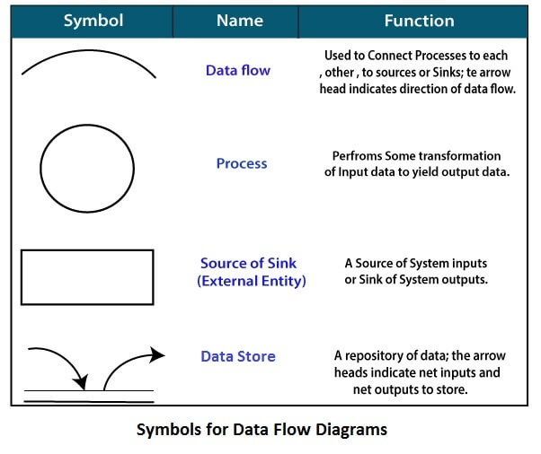

Level-0 Data flow diagram of **Noteffy**

It is also known as the fundamental system model, or context diagram represents the entire software requirement as a single bubble with input and output data denoted by incoming and outgoing arrows.

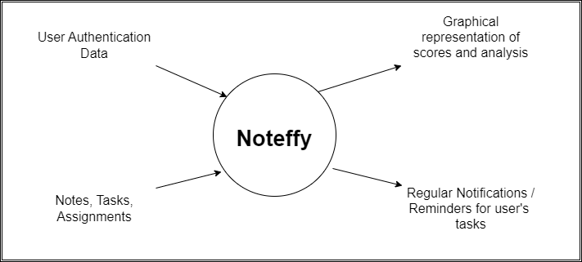

Level-1 Data flow diagram of **Noteffy**

In 1-level DFD, a context diagram is decomposed into multiple bubbles/processes. At this level, we highlight the system's main objectives and break down the high-level process of 0-level DFD into subprocesses.

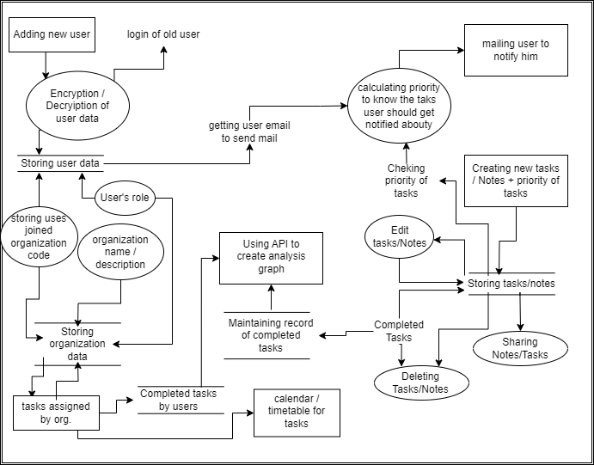

Level-2 Data flow diagram of **Noteffy**

2-level DFD goes one process deeper into parts of 1-level DFD. It can be used to project or record the specific/necessary details about the system’s functioning.

